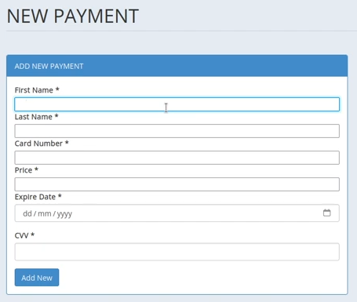

Payment forum located at reservation-system/admin/reservation.php
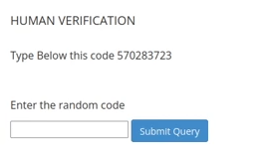

human verification forum located at reservation-system/admin/reservation.php

reservation-system/admin/reservation.php doesn't proceed when clicking "submit query" button under the "human verification" form. Nothing gets submitted to the sql database.
clicking to "add new" button under "add new card" form refreshes the page, nothing gets submitted to the sql database.
Exception at “$check="SELECT * FROM p” Line 271 of reservation-system/admin/reservation.php

deleting the "add new card" form fixes the bug.
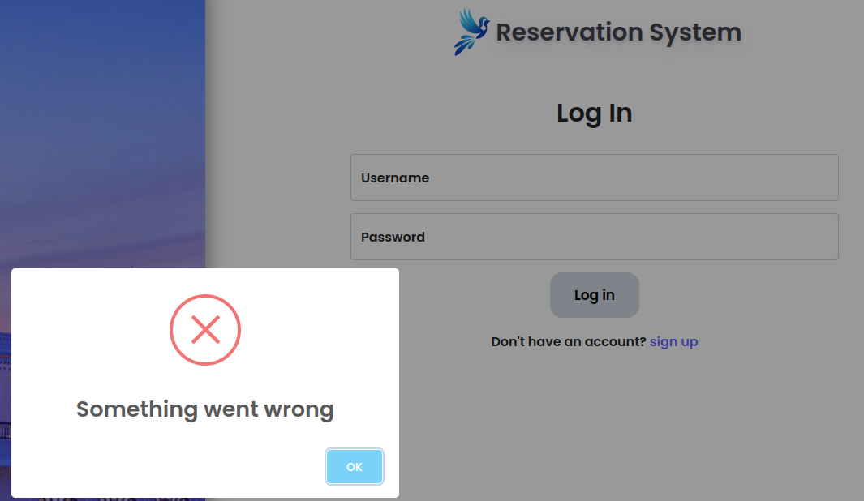
signup doesn't work:
